A Project Report
on

Sign Language Detection Using Deep Learning and MediaPipe Holistic

submitted in partial fulfillment of the requirements for the degree of
MSc Computer Science
in

Department of Computer Science and Applications

by
Ruchika Mayee Barik
(Roll No:03S24CS26)

under the guidance of
Dr. Amiya Kumar Sahu


Department of Computer Science and Applications
Sambalpur University, Jyoti Vihar, Burla,
Sambalpur, Odisha – 768019


Department of Computer Science and Applications
Sambalpur University, Jyoti Vihar, Burla,
Sambalpur, Odisha- 768019
Website: www.suniv.ac.in

Date: / / 2026

Undertaking
I declare that the project work presented in this report titled "Sign Language Detection Using Deep Learning and MediaPipe Holistic", submitted to the Department of Computer Science and Applications, Sambalpur University, Odisha, for the award of the M. Sc. in Computer Science, is my original work. I have not plagiarised or submitted the same work for the award of any other degree. In case this undertaking is found incorrect, I accept that my degree may be unconditionally withdrawn.

Ruchika Mayee Barik
Roll:03S24CS26


Department of Computer Science and Applications
Sambalpur University, Jyoti Vihar, Burla,
Sambalpur, Odisha- 768019
Website: www.suniv.ac.in

Date: / / 2026

Supervisor's Certificate
This is to certify that the project work in the report entitled "Sign Language Detection Using Deep Learning and MediaPipe Holistic" submitted by Ruchika Mayee Barik is a record of an original research work carried out by her under my supervision and guidance in partial fulfilment of the requirements for the award of the degree of MSc Computer Science.

Dr. Amiya Kumar Sahu
Assistant Professor
Department of Computer
Science and Applications
Sambalpur University,
Jyoti Vihar, Burla,
Odisha – 768019


Department of Computer Science and Applications
Sambalpur University, Jyoti Vihar, Burla,
Sambalpur, Odisha- 768019
Website: www.suniv.ac.in

Date: / / 2026

Declaration

I, Ruchika Mayee Barik, bearing Roll No. 03S24CS26, understand that plagiarism is defined as anyone or combination of the following:
- Uncredited verbatim copying of individual sentences, paragraphs or illustrations (such as graphs, diagrams etc.) from any source, published or unpublished, including the internet.
- Uncredited improper paraphrasing of pages or paragraphs (changing a few words or phrases, or rearranging the original sentence order).
- Uncredited verbatim copying of a major portion of a paper (or thesis chapter) without clear delineation of who did or wrote what.
I have made sure that all the ideas, expressions, graphs, diagrams etc. that are not a result of my work are properly credited. Long phrases or sentences that had to be used verbatim from published literature have been clearly identified using quotation marks.
I affirm that no portion of my work can be considered as plagiarism and I take full responsibility if such a complaint occurs. I understand fully well that the guide of this thesis may not be in a position to check for the possibility of such incidences of plagiarism in this body of work.

Place: Sambalpur University Ruchika Mayee Barik
Date: M.Sc(Computer Science) Roll no:03S24CS26


Department of Computer Science and Applications
Sambalpur University, Jyoti Vihar, Burla,
Sambalpur, Odisha- 768019
Website: www.suniv.ac.in

Certificate of Examination

Roll: O3S24CS26
Name: Ruchika Mayee Barik
Title of Project: Sign Language Detection Using Deep Learning and MediaPipe Holistic

We the below signed, after checking the report mentioned above and the official record of the student, hereby state our approval of the dissertation submitted in partial fulfilment of the requirements of the degree of Master of Science in Computer Science in the department of Computer Science and Applications, Sambalpur University, Odisha. We are satisfied with the volume, quality, and correctness of the work done by the student.

Dr. Chandra Sekhar Panda  Head, Department of Computer  Science and Applications  Sambalpur University | External Examiner | Internal Examiner

Acknowledgements
I would like to express my sincere gratitude to my supervisor, Dr. Amiya Kumar Sahu, Assistant Professor, Department of Computer Science and Applications, Sambalpur University, for his invaluable guidance, constant encouragement, and constructive feedback throughout the development of this project. His expertise in the field of computer vision and deep learning has been instrumental in shaping the direction and quality of this work.

I am also grateful to Dr. Chandra Sekhar Panda, Head of the Department of Computer Science and Applications, Sambalpur University, for providing the necessary facilities and support for completing this project.

I extend my thanks to the faculty members of the Department of Computer Science and Applications for their support and encouragement throughout my M.Sc. programme. I also acknowledge my classmates and friends for their moral support and encouragement during the development of this project.

Finally, I am indebted to my family for their unconditional love, patience, and motivation throughout my postgraduate studies. Their belief in my capabilities has been a constant source of strength.

Ruchika Mayee Barik

Abstract
Sign language is the primary mode of communication for the hearing-impaired community worldwide. However, the communication barrier between sign language users and non-users remains a significant challenge in everyday life. This project presents a real-time Sign Language Detection system developed using MediaPipe Holistic landmark extraction and a Long Short-Term Memory (LSTM) deep learning model.

The system captures video frames from a standard webcam and extracts 1,662 keypoints per frame from face, pose, left hand, and right hand landmarks using Google's MediaPipe Holistic framework. These keypoints are then fed into a stacked LSTM neural network that classifies sequences of 30 frames into target sign language gestures. The model currently recognises three signs — Good, Hello, and Thanks — achieving 100% test accuracy on the collected dataset through the application of data augmentation, BatchNormalization, L2 regularisation, and EarlyStopping callbacks.

The system is designed to be fully scalable, allowing new signs to be added at any time without modifying the core architecture. Simply recording new gesture sequences and retraining the model is sufficient to extend the vocabulary. The final system performs real-time gesture recognition with confidence probability visualisation displayed on screen, along with text-to-speech output of detected signs.

This project demonstrates the potential of combining computer vision landmark detection with temporal deep learning models for accessible and cost-effective sign language recognition using only standard laptop hardware.

Table of Contents
Undertaking…………………………………………………………………………………………….. | i
Supervisor's Certificate…………………………………………………………………………………  Declaration……………………………………………………………………………………………… | ii
Certificate of Examination…………………………………………………………………………… | iii
Acknowledgements……………………………………………………………………………………….. | iv
Abstract……………………………………………………………………………………………………. | v
List of Tables……………………………………………………………………………………………… | vi
List of Abbreviations…………………………………………………………………………………….. | vii
1. Introduction…………………………………………………………………………………………… | 1
1.1 Background and Motivation…………………………………………………………………………… | 1
1.2 Problem Statement……………………………………………………………………………………... | 2
1.3 Objectives……………………………………………………………………………………………… | 2
1.4 Scope of the Project……………………………………………………………………………………. | 3
2. Literature Review……………………………………………………………………………………… | 5
3. System Design and Methodology……………………………………………………………………… | 8
3.1 System Architecture……………………………………………………………………………………. | 8
3.2 MediaPipe Holistic Framework………………………………………………………………………... | 9
3.3 Data Collection………………………………………………………………………………………… | 10
3.4 Data Preprocessing and Augmentation………………………………………………………………… | 11
3.5 LSTM Model Architecture…………………………………………………………………………….. | 12
4. Implementation………………………………………………………………………………………… | 14
4.1 Development Environment……………………………………………………………………………. | 14
4.2 System Workflow……………………………………………………………………………………… | 15
4.3 Code Implementation………………………………………………………………………………… | 15
4.4 Keypoint Extraction…………………………………………………………………………………… | 15
4.5 Model Training……………………………………………………………………………………….. | 16
4.6 Real-Time Detection…………………………………………………………………………………… | 19
5.Results and Discussion………………………………………………………………………………… | 21
5.1 Dataset Summary………………………………………………………………………………………. | 21
5.2 Training Performance………………………………………………………………………………… | 21
5.3 Test Accuracy and Classification Report……………………………………………………………… | 22
5.4 Challenges and Solutions……………………………………………………………………………… | 23
6. Conclusion and Future Work…………………………………………………………………………. | 25
6.1 Conclusion…………………………………………………………………………………………….. | 25
6.2 Future Work…………………………………………………………………………………………… | 26
7. References……………………………………………………………………………………………... | 28

List of Tables
Table 3.1: Data Collection Parameters | 10
Table 3.2: LSTM Model Architecture (Improved) | 13
Table 4.1: Development Environment | 14
Table 4.2: Python Package Versions | 15
Table 5.1: Dataset Summary After Augmentation | 21
Table 5.2: Classification Report – Test Set | 22

List of Abbreviations
Abbreviation | Full Form
API | Application Programming Interface
CPU | Central Processing Unit
CV | Computer Vision
DL | Deep Learning
FPS | Frames Per Second
GPU | Graphics Processing Unit
IDE | Integrated Development Environment
ISL | Indian Sign Language
LSTM | Long Short-Term Memory
ML | Machine Learning
MP | MediaPipe
npy | NumPy Binary Array Format
ReLU | Rectified Linear Unit
RGB | Red Green Blue
RNN | Recurrent Neural Network
SLR | Sign Language Recognition
TTS | Text-to-Speech
VS Code | Visual Studio Code

Chapter 1: Introduction

1.1 Background and Motivation
Sign language is a complete, natural language used by millions of people in the hearing-impaired community worldwide. Unlike spoken languages, sign languages use a combination of hand gestures, facial expressions, and body movements to convey meaning. Indian Sign Language (ISL), like other sign languages, has a rich vocabulary and grammatical structure that is entirely distinct from spoken or written Hindi or English.

Despite its importance, sign language remains poorly understood by the general population, creating a significant communication barrier between the deaf and hearing communities. Traditional approaches to bridging this gap, such as human interpreters, are expensive, limited in availability, and not always accessible in real-time situations. An automated, real-time sign language detection system can significantly improve accessibility and communication for the hearing-impaired community.

Recent advances in computer vision, particularly landmark detection frameworks such as Google's MediaPipe Holistic, and deep learning architectures such as Long Short-Term Memory (LSTM) networks, have made real-time gesture recognition increasingly feasible on commodity hardware. These technologies enable accurate extraction of spatial and temporal features from standard webcam video streams without requiring expensive specialised equipment such as depth cameras or data gloves.

1.2 Problem Statement
Existing sign language recognition systems often require specialised hardware such as depth cameras, data gloves, or Microsoft Kinect sensors, making them expensive and impractical for everyday use. Furthermore, many systems are designed for static gesture recognition and fail to capture the dynamic, sequential nature of sign language, which inherently involves motion over time. There is a clear need for a low-cost, real-time, and scalable system capable of recognising dynamic sign language gestures using only a standard webcam and consumer-grade computing hardware.
A secondary challenge is inter-class similarity: certain sign language gestures share similar hand configurations at particular moments in their execution, making accurate temporal classification difficult without a model that captures the full motion sequence rather than individual frames.

1.3 Objectives
The primary objectives of this project are as follows:
- To develop a real-time sign language detection system using a standard webcam and Python-based tools.
- To extract spatial and temporal keypoint features using the MediaPipe Holistic framework, capturing 1,662 landmark values per frame.
- To train a Long Short-Term Memory (LSTM) neural network incorporating BatchNormalization and L2 regularisation for robust temporal sequence classification.
- To apply data augmentation techniques to improve model generalisation without requiring additional recording sessions.
- To design a scalable system architecture that allows new sign language gestures to be added at any time by recording new sequences and retraining the model.
- To evaluate system performance using classification accuracy, precision, recall, and F1-score metrics on a held-out test set.

1.4 Scope of the Project
The current scope of the project focuses on recognising a set of self-recorded sign language gestures. The initial implementation recognises three signs: Good (thumbs up), Hello (hand wave), and Thanks (hand to chest gesture). The system is designed to be fully extensible new signs such as 'Sorry', 'Please', 'Yes', 'No', 'Help', and others can be incorporated simply by recording additional sequences and retraining the model without any changes to the core system architecture.

The system operates in real time using a standard laptop webcam and requires no specialised hardware. All processing is performed on a standard CPU, and the system is implemented entirely in Python 3.10 using freely available open-source libraries.

Chapter 2: Literature Review
Sign language recognition has been an active area of research in computer vision and human-computer interaction for several decades. Early approaches relied heavily on specialised hardware such as instrumented data gloves and depth-sensing cameras. Mitra and Acharya (2007) provided a comprehensive survey of gesture recognition techniques, categorising them into appearance-based and model-based approaches and identifying the limitations of sensor-based methods for real-world deployment.

With the advancement of deep learning, Convolutional Neural Networks (CNNs) became widely used for static gesture recognition from image data. Molchanov et al. (2016) demonstrated the effectiveness of 3D CNNs for dynamic gesture classification from depth video streams. However, sign language involves temporal sequences of gestures that require models capable of capturing long-range temporal dependencies.

Recurrent Neural Networks (RNNs), and particularly Long Short-Term Memory (LSTM) networks introduced by Hochreiter and Schmidhuber (1997), have proven effective for capturing temporal dependencies in sequential data. LSTMs address the vanishing gradient problem that limits standard RNNs, making them well-suited to modelling the temporal structure of sign language sequences.

Koller et al. (2017) demonstrated the effectiveness of combining CNN feature extraction with RNN temporal modelling for continuous sign language recognition from video. Their work highlighted the importance of capturing both spatial and temporal features for accurate recognition of dynamic gestures. The introduction of MediaPipe by Lugaresi et al. (2019) at Google provided a framework for real-time, efficient landmark detection across face, hands, and body pose without requiring GPU hardware. MediaPipe Holistic integrates face, pose, and hand landmark detection in a single pipeline and has been widely adopted in gesture recognition research.

Nicholas Renotte (2021) demonstrated an action detection system using MediaPipe Holistic and stacked LSTM networks, achieving high accuracy on a small set of actions using a standard webcam. This work forms the foundational methodology adopted in the present project. The present work extends this approach by incorporating data augmentation, BatchNormalization, L2 regularisation, EarlyStopping with best-weight restoration, and an improved real-time detection logic incorporating frame agreement, confidence gap thresholding, and cooldown mechanisms to reduce false detections.

Pigou et al. (2018) investigated the use of convolutional and recurrent architectures for isolated sign recognition and found that temporal modelling significantly outperformed frame-level classification. Their findings validate the LSTM-based approach adopted in this project for capturing the sequential dynamics of sign language gestures.

The literature collectively demonstrates that landmark-based approaches using MediaPipe, combined with LSTM temporal modelling, represent an effective and computationally efficient methodology for real-time sign language recognition without requiring specialised hardware. The present project builds upon this foundation while addressing practical challenges of inter-class similarity and false detection through improved training and detection mechanisms.

Chapter 3: System Design and Methodology

3.1 System Architecture
The proposed system follows a five-stage sequential pipeline. Each stage is implemented as a modular Python function, allowing independent modification and extension of individual components without affecting the rest of the system.

Stage 1 — Video Capture: A standard webcam ca 30 frames per second using OpenCV's VideoCapture interface. Each frame is passed to the MediaPipe Holistic model for landmark detection.
Stage 2 — Landmark Extraction: MediaPipe Holistic extracts 1,662 keypoint values per frame, comprising 33 pose landmarks (132 values with visibility score), 468 face mesh landmarks (1,404 values), 21 left hand landmarks (63 values), and 21 right hand landmarks (63 values). If any body part is not detected in a given frame, a zero-filled array of the appropriate size is substituted to maintain a consistent input shape.
Stage 3 — Sequence Construction: Keypoints from 30 consecutive frames are accumulated to form a single input sequence of shape (30, 1662). This 30-frame temporal window captures the complete dynamic motion of a sign gesture, sampled at approximately one second of video.
Stage 4 — LSTM Classification: The sequence is passed to the trained LSTM neural network, which outputs a probability distribution over all target sign classes. The predicted class is determined by the argmax of the output probabilities, subject to confidence and frame agreement filters.
Stage 5 — Display and Output: The predicted sign label, confidence probabilities, and a rolling text sentence are displayed on the video frame in real time. Upon stable detection, a text-to-speech engine announces the detected sign aloud.

3.2 MediaPipe Holistic Framework
MediaPipe Holistic is a cross-platform framework developed by Google that provides simultaneous detection and tracking of face, body pose, and hand landmarks from a single RGB video frame. The framework uses a graph-based processing architecture that allows efficient parallel execution of multiple detection models within a single inference pass.
For this project, the MediaPipe Holistic model is configured with a minimum detection confidence of 0.6 and minimum tracking confidence of 0.6, with model complexity set to 1 for a balance between accuracy and processing speed. The framework provides normalised landmark coordinates (x, y, z) in the range [0, 1] relative to the image dimensions, making the extracted features resolution-independent and suitable for training across different camera setups.

3.3 Data Collection
Training data was collected using a self-recording procedure in which the researcher performed each sign gesture in front of the webcam under consistent lighting and background conditions. For each sign, sequences were recorded, each comprising 30 frames. The keypoints extracted from each frame were saved as NumPy array files (.npy format) organised in a hierarchical directory structure: MP_Data/[sign_name]/[sequence_number]/[frame_number].npy.

Parameter | Value | Description
Sequences per sign (Good) | 160 | Number of video recordings
Sequences per sign (Hello) | 101 | Number of video recordings
Sequences per sign (Thanks) | 100 | Number of video recordings
Frames per sequence | 30 | Frames per recording (~1 second)
Keypoints per frame | 1,662 | Total landmark values extracted
Data format | .npy | NumPy binary array format
Storage structure | MP_Data/sign/seq/frame.npy | Hierarchical directory
Table 3.1: Data Collection Parameters

3.4 Data Preprocessing and Augmentation
The collected keypoint sequences are loaded and assembled into a dataset array of shape (N, 30, 1662), where N is the total number of sequences. To improve model generalisation without requiring additional recording sessions, data augmentation is applied: for each original sequence, two additional noisy copies are created by adding Gaussian noise with a standard deviation of 0.002 to all keypoint values. This effectively triples the dataset size while preserving the temporal structure of each gesture.

Labels are encoded as one-hot vectors using Keras's to_categorical function. The dataset is split into training and test sets using a 85:15 ratio with stratification to ensure balanced class representation in both sets. A random seed of 42 is fixed for reproducibility.

3.5 LSTM Model Architecture
The improved classification model is a stacked LSTM network implemented using TensorFlow and Keras. The architecture incorporates BatchNormalization after each LSTM layer to stabilise training and accelerate convergence, L2 regularisation on all LSTM and Dense layers to reduce overfitting, and Dropout layers to further prevent memorisation of training data. The output layer uses a softmax activation function to produce a probability distribution over all sign classes.
# | Layer Type | Units | Activation | Notes
1 | LSTM | 128 | tanh | return_sequences=True, L2
2 | BatchNormalization | – | – | Stabilises training
3 | Dropout | – | – | rate=0.3
4 | LSTM | 256 | tanh | return_sequences=True, L2
5 | BatchNormalization | – | – | Stabilises training
6 | Dropout | – | – | rate=0.3
7 | LSTM | 128 | tanh | return_sequences=False, L2
8 | BatchNormalization | – | – | Stabilises training
9 | Dropout | – | – | rate=0.2
10 | Dense | 128 | ReLU | L2 regularisation
11 | BatchNormalization | – | –
12 | Dropout | – | – | rate=0.2
13 | Dense | 64 | ReLU
14 (Output) | Dense | N (signs) | Softmax | N = number of recorded signs
Table 3.2: LSTM Model Architecture (Improved)
The model is compiled with the Adam optimiser at an initial learning rate of 0.001 and categorical cross-entropy loss. Training uses three callbacks: EarlyStopping monitors validation accuracy with patience of 30 epochs and restores best weights; ModelCheckpoint saves the best model to disk; and ReduceLROnPlateau halves the learning rate when validation accuracy plateaus for 15 epochs, down to a minimum of 1e-
Workflow Diagram
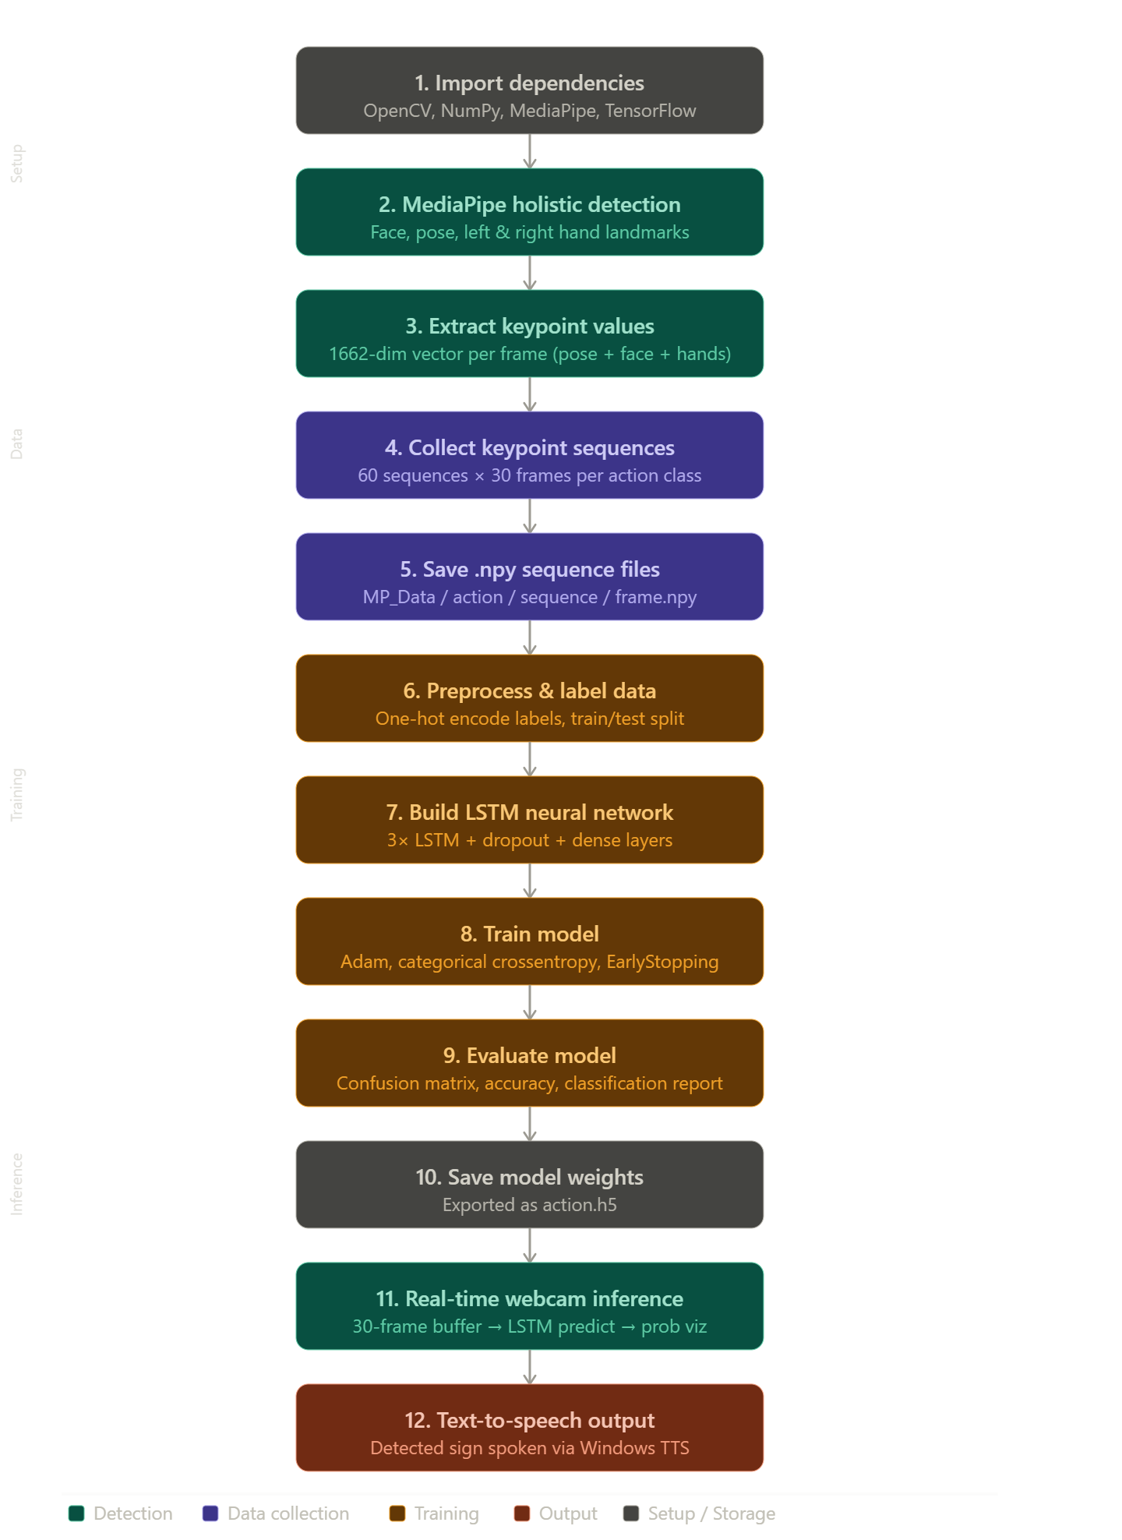

Chapter 4: Implementation

4.1 Development Environment
The project is implemented entirely in Python 3.10 using a virtual environment to manage dependencies. The development and execution environment consists of a standard HP laptop running Windows 11 with a built-in webcam. No GPU acceleration is required, and all processing is performed on the CPU.

Component | Version / Details
Python | 3.10.8
TensorFlow / Keras | 2.12.0
MediaPipe | 0.10.5
OpenCV | 4.13.0
NumPy | 1.23.5
scikit-learn | 1.2.0
Matplotlib | 3.7.x
SciPy | 1.10.x
Development IDE | Visual Studio Code with Jupyter Extension
Operating System | Windows 11
Hardware | Standard HP Laptop with Built-in Webcam
Table 4.1: Development Environment

4.2 System Workflow

1. Data Acquisition & Preprocessing

MediaPipe Holistic Tracking: Leverages the MediaPipe Holistic model to detect and track keypoints across the face, pose (body), and both hands in real-time from video frames.

Frame Transformation: Converts input BGR images (OpenCV standard) to RGB for MediaPipe processing, then back to BGR for visualization.

Keypoint Extraction: Landmarks are flattened and concatenated into a single feature vector per frame. If a landmark is not detected, it is padded with a zero-array to maintain consistent input shapes.

2. Dataset Preparation

Sequence Collection: Data is organized into sequences (e.g., 60 sequences per sign) with a fixed length of 30 frames each to capture the temporal motion of a sign.

Storage Architecture: Each frame’s keypoints are saved as a .npy (NumPy array) file within structured directories categorized by action name and sequence number.

Feature Engineering: Data is labeled using a label_map and converted into a one-hot encoded format for the neural network.

3. Model Architecture & Training

LSTM Neural Network: Utilizes Long Short-Term Memory (LSTM) layers, which are specifically designed to handle temporal "sequence" data by remembering previous frame information.

Optimization:

Loss Function: Categorical Crossentropy for multi-class classification.

Callbacks: Implements TensorBoard for logging and ReduceLROnPlateau to dynamically adjust the learning rate when validation loss plateaus.

Checkpoints: Automatically saves the "best" performing version of the model (best_action.h5) based on validation loss.

4. Real-Time Inference (Proposed)

Windowing: The system maintains a "sliding window" of the last 30 frames.

Prediction: Once the window is full, the LSTM model predicts the action with a probability score.

Display: The recognized sign is overlaid on the video feed in real-time.

Technical Summary Table
Component | Specification
Detection Framework | MediaPipe Holistic
Input Features | 1662 keypoints per frame
Temporal Window | 30 Frames per sequence
Model Type | Sequential LSTM
Training Split | 85% Train / 15% Test

4.3 Code Implementation

1.Import dependencies

Cell 1

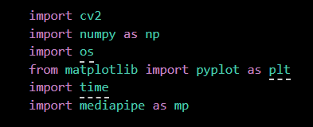

import cv2: Imports the OpenCV library, which provides the essential tools for real-time image processing and camera video capture.

import numpy as np: Imports NumPy for efficient numerical operations, allowing you to handle video frames and landmark coordinates as high-performance arrays.

import os: Imports the Operating System module to manage file paths and directories for saving or loading your collected gesture data.

from matplotlib import pyplot as plt: Imports a plotting library used to visualize single frames or data distributions, often for debugging during the training process.

import time: Imports the time module to track intervals between frames or to create "countdown" delays during the data collection phase.

import mediapipe as mp: Imports the core Google MediaPipe library, which contains the pre-trained deep learning models for body and hand tracking.

2.KEYPOINTS USING MP HOLISTIC

Cell 2

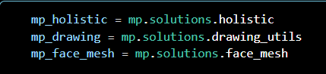

mp_holistic = mp.solutions.holistic: Accesses the integrated Holistic solution that simultaneously tracks pose, face, and hand landmarks. It provides the high-level API needed to initialize the AI model and process video frames for coordinate extraction.

mp_drawing = mp.solutions.drawing_utils: Provides a specialized set of utility functions used to draw landmarks and connections onto the image. This is the "artist" module that visually overlays the skeletal structure onto your real-time video feed.

mp_face_mesh = mp.solutions.face_mesh: Specifically targets the 468-point 3D facial topology for detailed tracking of expressions and lip movements. While often included in the Holistic model, this direct reference allows for independent face-specific mesh configurations.

Cell 3

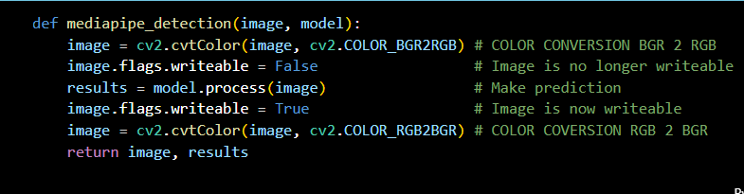The function mediapipe_detection serves as the primary data processing pipeline that prepares camera frames for the AI model and retrieves the detection data.

def mediapipe_detection(image, model):

Defines the function, taking a raw video frame (image) and the initialized Holistic model (model) as inputs.

image = cv2.cvtColor(image, cv2.COLOR_BGR2RGB)

Converts the image from BGR (OpenCV default) to RGB color space, which is the specific format required by MediaPipe models for accurate processing.

image.flags.writeable = False

Sets the image's memory buffer to a non-writeable state to optimize performance and reduce memory overhead during the AI's scan.

results = model.process(image)

Executes the actual landmark detection (inference), where the AI analyzes the pixels to calculate the $(x, y, z) $ coordinates of the face, body, and hands.

image.flags.writeable = True

Restores the image buffer's writeable status so that it can be modified or annotated in later steps of the code.

image = cv2.cvtColor(image, cv2.COLOR_RGB2BGR)

Converts the image back from RGB to BGR so that OpenCV can display the video colors correctly on your monitor.

return image, results

Sends the processed video frame and the newly calculated landmark data back to the main loop for further use.

Cell 4

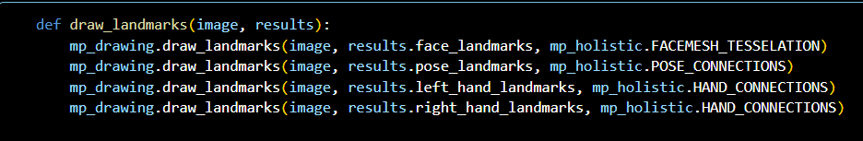

This function acts as a visualizer that overlays detected skeletal landmarks onto the video frame for real-time validation.

def draw_landmarks(image, results): Defines a custom function that takes the current video frame (image) and the AI's detection data (results) as inputs to perform the drawing operations.

mp_drawing.draw_landmarks(image, results.face_landmarks, mp_holistic.FACEMESH_TESSELATION) Uses MediaPipe's drawing utilities to render a dense triangular mesh over the detected face landmarks on the image.

mp_drawing.draw_landmarks(image, results.pose_landmarks, mp_holistic.POSE_CONNECTIONS) Draws the body's skeletal "stick figure" by connecting key points like shoulders and elbows based on the pose landmark data.

mp_drawing.draw_landmarks(image, results.left_hand_landmarks, mp_holistic.HAND_CONNECTIONS) Plots the 21 key points of the left hand and draws lines between the finger joints to visualize hand gestures.

mp_drawing.draw_landmarks(image, results.right_hand_landmarks, mp_holistic.HAND_CONNECTIONS) Performs the same drawing operation for the right hand, ensuring both hands are tracked and visualized independently.

Cell 5

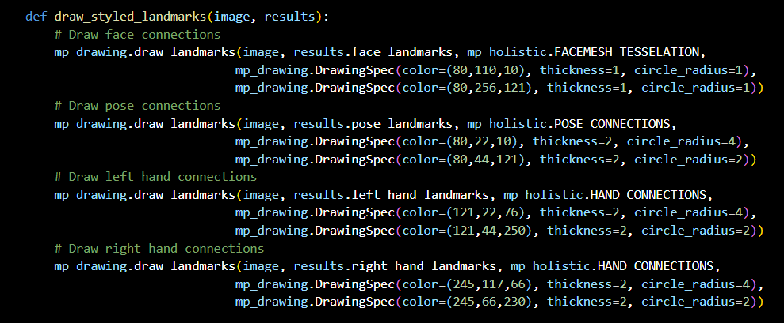

The draw_styled_landmarks function applies custom visual styles—such as specific colors and thicknesses—to the landmarks detected by the AI.

def draw_styled_landmarks(image, results): This line defines a custom function that accepts the current video frame (image) and the AI's detection data (results) to perform customized drawing operations.

Draw face connections A comment indicating that the following block of code will handle the visualization of facial landmarks.

mp_drawing.draw_landmarks(image, results.face_landmarks, mp_holistic.FACEMESH_TESSELATION, ...) This command draws the detailed facial mesh. It uses two DrawingSpec parameters to set a thin, subtle style (thickness=1, circle_radius=1) using green-toned BGR color codes.

Draw pose connections A comment marking the start of the code that visualizes the body's skeletal structure.

mp_drawing.draw_landmarks(image, results.pose_landmarks, mp_holistic.POSE_CONNECTIONS, ...) This draws the main body "stick figure". It uses a thicker style (thickness=2) and larger dots (circle_radius=4) with a bright green and dark red color scheme to make the body posture clear.

Draw left hand connections A comment indicating that the next block of code will visualize the landmarks of the left hand.

mp_drawing.draw_landmarks(image, results.left_hand_landmarks, mp_holistic.HAND_CONNECTIONS, ...) This renders the 21 points of the left hand. It uses a distinct purple and pink BGR color mapping (121, 44, 250) to help distinguish the left hand from other parts of the body.

Draw right hand connections A comment marking the final block of code for right-hand visualization.

mp_drawing.draw_landmarks(image, results.right_hand_landmarks, mp_holistic.HAND_CONNECTIONS, ...) This renders the landmarks for the right hand. It uses a different high-contrast color scheme (orange and pinkish-purple) to ensure the right hand is visually distinct from the left.

3.EXTRACT KEYPOINTS VALUES

Cell 6

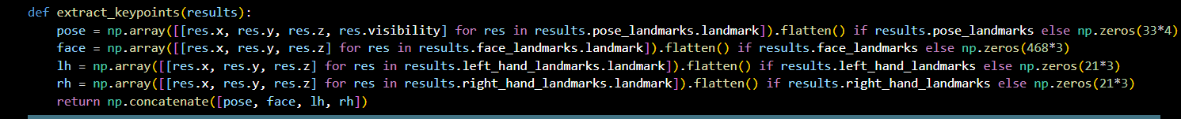

This function is the "Data Formatter." While the previous functions were for seeing the landmarks, this one converts those landmarks into a long list of numbers (a NumPy array) that your AI model can actually learn from.

def extract_keypoints(results):

Defines a function that takes the results object (containing all coordinates) and prepares it for data collection or prediction.

pose = np.array([[res.x, res.y, res.z, res.visibility] for res in results.pose_landmarks.landmark]).flatten() if results.pose_landmarks else np.zeros(33*4)

Extraction: It loops through the 33 pose landmarks to get $x, y, z$ and a visibility score.

Flattening: It turns that list into a single flat row of numbers.

Error Handling: If the AI doesn't see a body, it creates a row of zeros (np.zeros) so the code doesn't crash.

face = np.array([[res.x, res.y, res.z] for res in results.face_landmarks.landmark]).flatten() if results.face_landmarks else np.zeros(468*3)

Extracts coordinates for the 468 face mesh points and flattens them into a row of 1,404 numbers ($468 \times 3$).

If no face is detected, it fills that space with zeros.

lh = np.array([[res.x, res.y, res.z] for res in results.left_hand_landmarks.landmark]).flatten() if results.left_hand_landmarks else np.zeros(21*3)

Extracts the 21 keypoints for the left hand ($21 \times 3 = 63$ numbers).

Essential for sign language; if the left hand is out of frame, it provides 63 zeros.

rh = np.array([[res.x, res.y, res.z] for res in results.right_hand_landmarks.landmark]).flatten() if results.right_hand_landmarks else np.zeros(21*3)

Same as above, but for the 21 points of the right hand.

return np.concatenate([pose, face, lh, rh])

The Big List: This joins (concatenates) all four groups into one giant array of 1,662 numbers.

This single array represents exactly how you were positioned in that specific frame of video.

Cell 7

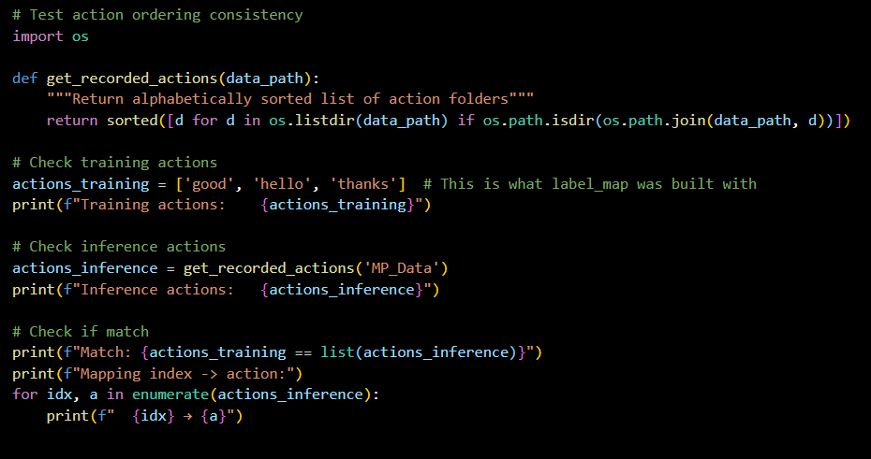

This cell ensures that the labels your AI model learned during training (like "hello" or "thanks") perfectly match the folders on your computer during inference.

Test action ordering consistency

A comment indicating that this block verifies if the order of actions is consistent across training and testing.

import os

Imports the Operating System module to interact with your computer's file system.

def get_recorded_actions(data_path):

Defines a function that scans a specific folder to find all the different sign language categories you have recorded.

return sorted([d for d in os.listdir(data_path) if os.path.isdir(os.path.join(data_path, d))])

This line looks inside your data folder, finds only the sub-directories (ignoring files), and sorts them alphabetically to ensure the order is always the same.

actions_training = ['good', 'hello', 'thanks']

Creates a manual list of the exact actions your model was originally trained to recognize.

print(f"Training actions: {actions_training}")

Displays the list of training labels on the screen for you to review.

actions_inference = get_recorded_actions('MP_Data')

Calls your function to see what folders actually exist in your 'MP_Data' directory right now.

print(f"Inference actions: {actions_inference}")

Displays the list of labels found on your disk to compare them with the training list.

print(f"Match: {actions_training == list(actions_inference)}")

Performs a logical check; it prints True if the lists are identical and in the same order, or False if there is a mismatch.

for idx, a in enumerate(actions_inference):

Starts a loop that goes through each label and assigns it a number (index), starting from 0.

print(f" {idx} -> {a}")

Prints the final mapping (e.g., 0 -> good), which is exactly how the AI will "label" its predictions during real-time sign language detection.

4.SETUP FOLDERS FOR COLLECTION

Cell 8

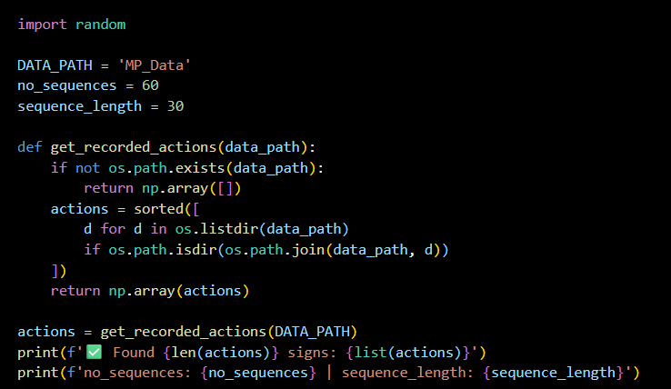

This cell handles the data structure setup, defining how many video samples you are collecting and automatically identifying your sign language categories from your folders.

import random: Imports the Python module used for generating random numbers, often used later to shuffle data for training.

DATA_PATH = 'MP_Data': Sets the name of the main folder where all your extracted landmark data will be saved on your disk.

no_sequences = 60: Defines that you will collect 60 separate videos (sequences) for each sign language action.

sequence_length = 30: Specifies that each video will consist of 30 frames of data.

def get_recorded_actions(data_path):: Starts the definition of a function designed to scan your data folder and see which signs you have already recorded.

if not os.path.exists(data_path):: A safety check to see if the main data folder actually exists yet.

return np.array([]): If the folder is missing, it returns an empty list so the program doesn't crash.

actions = sorted([...]): This complex line looks through the directory, finds only the folders (ignoring files), and sorts them alphabetically so your labels are always in the same order.

return np.array(actions): Sends the final list of detected signs back to the main program as a high-performance array.

actions = get_recorded_actions(DATA_PATH): Runs the function above to populate your actions variable with the names of your signs (e.g., 'hello', 'thanks').

print(f'✅ Found {len(actions)} signs: {list(actions)}'): Displays a success message showing the total count and names of the signs found in your folders.

print(f'no_sequences: {no_sequences} | sequence_length: {sequence_length}'): Prints your data collection settings to the screen to confirm the total amount of data being processed.

Cell 9

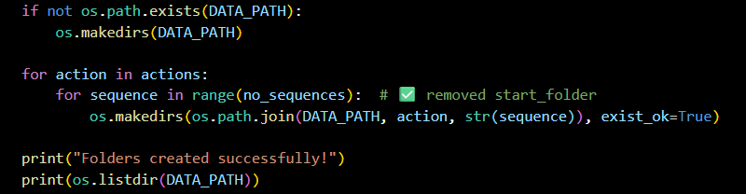

This cell segment automates the creation of a hierarchical directory structure to store your collected landmark data.

if not os.path.exists(DATA_PATH): Checks if the main root directory (defined earlier as 'MP_Data') already exists on your computer.

os.makedirs(DATA_PATH) If the root directory does not exist, this command creates it to ensure there is a home for your data.

for action in actions: Starts a loop that iterates through every sign language gesture you intend to collect (e.g., 'hello', 'thanks', 'good').

for sequence in range(no_sequences): Starts a nested loop to create sub-folders for each individual video sample (sequence) you will record for that specific action.

os.makedirs(os.path.join(DATA_PATH, action, str(sequence)), exist_ok=True) Creates the final specific folder path (e.g., MP_Data/hello/0); the exist_ok=True parameter prevents the program from crashing if the folder already exists.

print("Folders created successfully!") Displays a confirmation message in the notebook once the entire directory structure has been built.

print(os.listidr(DATA_PATH)) Prints a list of the top-level folders within 'MP_Data' to verify that the action categories were created correctly.

Cell 10

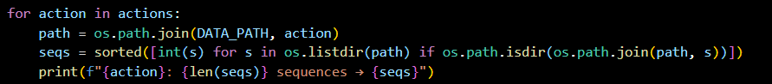

This cell is used to verify and audit your data collection by counting how many video sequences exist for each sign language gesture.

for action in actions:

This initiates a loop that iterates through each specific sign gesture (e.g., "hello", "thanks") stored in your actions list.

path = os.path.join(DATA_PATH, action)

This creates a direct file path string by combining the root data folder (DATA_PATH) with the specific gesture folder name currently being processed.

seqs = sorted([int(s) for s in os.listdir(path) if os.path.isdir(os.path.join(path, s))])

This line scans the gesture folder and creates a list of all sub-folders representing individual video sequences.

It converts the folder names to integers and sorts them numerically to ensure they appear in a logical order (0, 1, 2, etc.) rather than just alphabetical order.

print(f"{action}: {len(seqs)} sequences -> {seqs}")

This displays a summary for each gesture, showing the action name, the total number of recorded sequences found, and a list of the sequence ID numbers.

Cell 11

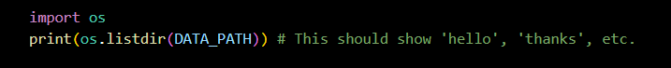

import os: This line imports the built-in Python Operating System module, which allows the program to interact with your computer's file system.

print(os.listdir(DATA_PATH)): This command retrieves a list of all files and folders located inside the directory specified by DATA_PATH and displays them on the screen.

5.COLLECT KEYPOINTS VALUES FOR TRAINING & TESTING

Cell 12

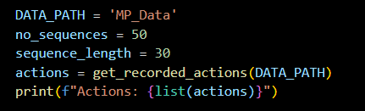

Based on this cell the data collection parameters are set up:

DATA_PATH = 'MP_Data': This line defines a string variable that sets the name of the root directory where your extracted landmark data is stored on your system.

no_sequences = 50: This sets a variable to 50, indicating that you intend to process or collect 50 separate video samples (sequences) for every sign language gesture.

sequence_length = 30: This variable specifies that each individual video sequence will consist of 30 frames of landmark data.

actions = get_recorded_actions(DATA_PATH): This calls a previously defined function to scan the 'MP_Data' folder and automatically retrieve the names of the sign language actions you have recorded.

print(f"Actions: {list(actions)}"): This prints a formatted string to the console to display the final list of action labels (gestures) found in your data directory.

Cell 12

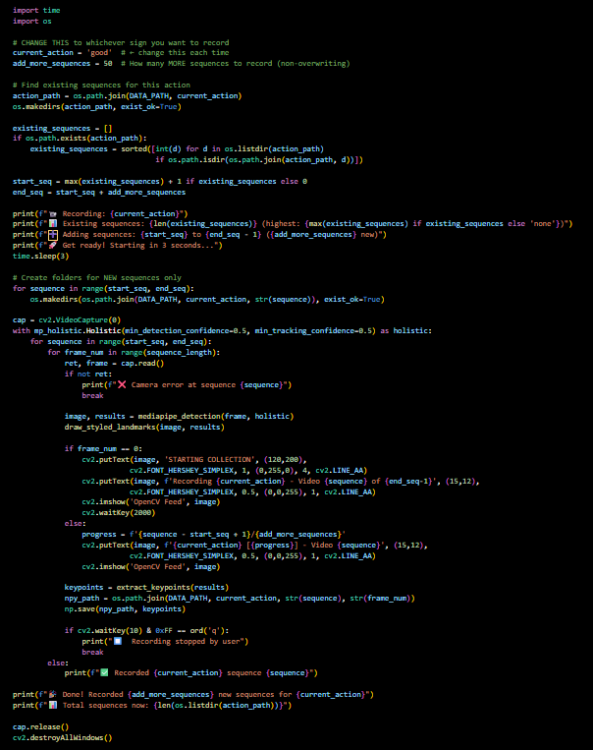

This cell is the Data Collection Engine for your project. Its job is to open your webcam, track your movements using MediaPipe, and save those movements as numerical data files (.npy) so your AI model can learn from them later.

1. Configuration and Path Setup

import time, import os: Imports essential modules for handling delays and file directories.

current_action = 'good': Sets the specific sign you are about to record; you change this manually for each gesture.

add_more_sequences = 50: Defines how many new video samples you want to record in this session.

action_path = os.path.join(DATA_PATH, current_action): Creates the file path for the specific gesture you are recording.

os.makedirs(action_path, exist_ok=True): Ensures the folder for that gesture exists on your computer.

2. Smart Folder Management

existing_sequences = [...]: Scans your folder to see how many sequences you have already recorded so it doesn't overwrite old data.

start_seq = max(existing_sequences) + 1 ...: Automatically calculates the next available folder number (e.g., if you have folders 0-49, it will start the new recording at 50).

end_seq = start_seq + add_more_sequences: Sets the target number for where the recording session should stop.

3. User Feedback and Prep

print(...): Several lines display status updates to your console, such as "Get ready! Starting in 3 seconds..."

time.sleep(3): Pauses the program for 3 seconds to give you time to get into position in front of the camera.

for sequence in range(start_seq, end_seq): os.makedirs(...): Physically creates the new sub-folders on your hard drive before the recording starts.

4. The Recording Loop (Webcam and AI)

cap = cv2.VideoCapture(0): Connects to your primary webcam.

with mp_holistic.Holistic(...) as holistic:: Initializes the MediaPipe AI model with specific confidence thresholds for tracking accuracy.

for sequence in range(start_seq, end_seq):: Loops through each video sample you need to collect.

for frame_num in range(sequence_length):: Loops through the 30 individual frames that make up one single gesture.

ret, frame = cap.read(): Grabs a single image frame from your webcam.

image, results = mediapipe_detection(frame, holistic): Sends that frame to your AI "translator" function to find your landmarks.

draw_styled_landmarks(image, results): Draws the colored dots and lines on the screen so you can see if the AI is tracking you correctly.

5. On-Screen Display (GUI)

if frame_num == 0:: If it is the very first frame of a gesture, it displays "STARTING COLLECTION" in green text on your video feed.

cv2.putText(...): Overlays text on the video showing which gesture you are recording and your progress (e.g., "Recording good - Video 55 of 100").

cv2.imshow('OpenCV Feed', image): Shows the live video window on your desktop.

6. Data Saving and Cleanup

keypoints = extract_keypoints(results): Converts the AI's tracking results into a list of 1,662 numbers.

npy_path = os.path.join(...): Creates a unique filename for that specific frame (e.g., MP_Data/good/50/0.npy).

np.save(npy_path, keypoints): Saves those numbers to your hard drive. This is the "memory" of the gesture.

if cv2.waitKey(10) & 0xFF == ord('q'): break: Allows you to stop the recording at any time by pressing the 'q' key.

cap.release(), cv2.destroyAllWindows(): Properly closes the camera and closes all pop-up windows once the task is finished.

Cell 13

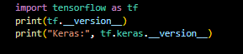

This cell is the "Health Check" for your machine learning environment. It ensures that the core deep learning libraries are installed and confirms which versions you are using.

import tensorflow as tf: Loads the TensorFlow library, which is the primary framework used to build and train your neural network.

print(tf.__version__): Displays the specific version of TensorFlow currently installed (e.g., 2.10.0). This is vital because code for older versions (TensorFlow 1.x) is often incompatible with 2.x.

print("Keras:", tf.keras.__version__): Checks the version of Keras, the high-level API that sits on top of TensorFlow to make building deep learning models more user-friendly.

Cell 14

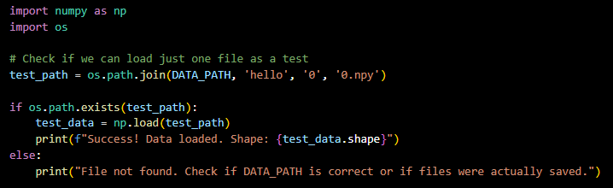

This cell is a Data Integrity Test. Its purpose is to verify that your previous data collection steps actually worked by attempting to load a single saved landmark file from your hard drive.

1. Library Imports

import numpy as np: Loads the NumPy library, which is required to read the .npy files where your keypoint data is stored.

import os: Loads the Operating System module to handle the file paths.

2. Path Construction

test_path = os.path.join(DATA_PATH, 'hello', '0', '0.npy'):

This creates a specific path to a single frame of data.

It targets the 'hello' action, the first video sequence ('0'), and the very first frame ('0.npy').

3. The Loading Test

if os.path.exists(test_path):: This checks if that specific file actually exists on your computer.

test_data = np.load(test_path): If the file is found, NumPy reads the binary data into a variable called test_data.

print(f"Success! Data loaded. Shape: {test_data.shape}"):

This confirms everything worked.

The Shape is the most important part; for this project, it should show (1662,). This tells you that all 1,662 landmarks (pose, face, and hands) were captured correctly for that frame.

4. Error Handling

else: print("File not found..."): If this message appears, it means the data collection failed or the DATA_PATH is pointing to the wrong folder.

6.PREPROCESS DATA & CREATE LABELS AND FEATURES

Cell 15

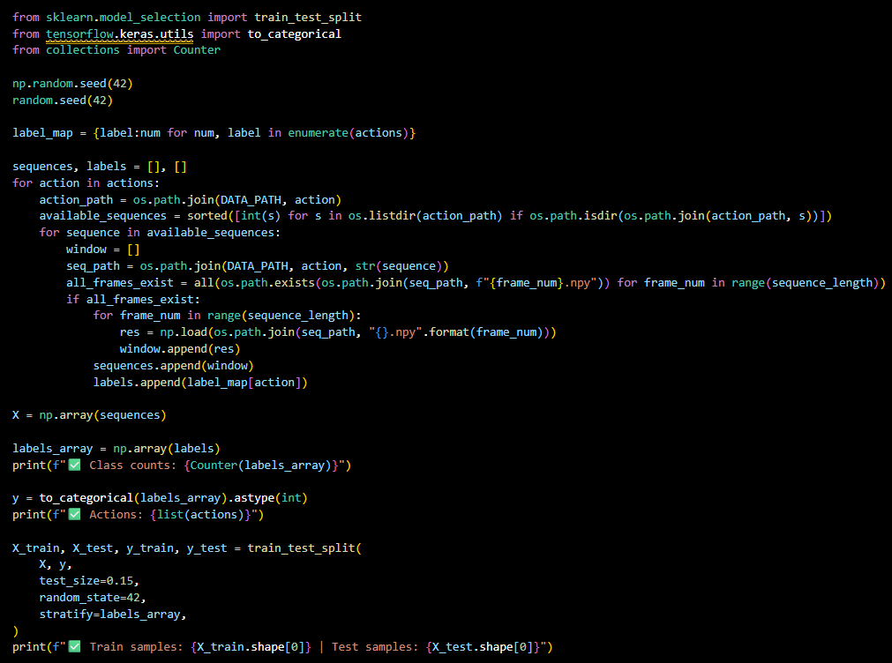

This cell represents the Data Preparation and Partitioning phase, where raw landmark files are organized into a format suitable for training a Deep Learning model.

1. Library Imports and Reproducibility

from sklearn.model_selection import train_test_split: Imports the utility to split your dataset into training and testing subsets.

from tensorflow.keras.utils import to_categorical: Imports a tool to convert integer labels into "One-Hot Encoded" vectors (e.g., converting label 0 to [1, 0, 0]).

np.random.seed(42) and random.seed(42): Sets a fixed seed for random number generators to ensure that your data splits are identical every time you run the code, which is vital for scientific reproducibility.

2. Label Mapping

label_map = {label:num for num, label in enumerate(actions)}: Creates a dictionary that maps your string actions (like "hello") to numbers (0, 1, 2) because neural networks require numerical inputs.

3. Data Loading and Sequence Assembly

sequences, labels = [], []: Initializes empty lists to store the processed video features ($X$) and their corresponding labels ($y$).

for action in actions:: Begins a loop to iterate through every gesture category you have recorded.

all_frames_exist = all(...): Performs an integrity check to ensure that all 30 frames for a specific video sequence actually exist on the disk before attempting to load them.

res = np.load(...): Loads the individual .npy file containing the 1,662 landmarks for a specific frame.

window.append(res): Groups these frames into a "window" or sequence, representing one complete performance of a sign.

sequences.append(window) and labels.append(label_map[action]): Saves the completed 30-frame video sequence and its numerical label into the main data lists.

4. Array Conversion and Preprocessing

X = np.array(sequences): Converts the list of sequences into a 3D NumPy array with the shape (total_samples, 30, 1662).

print(f"Class counts: {Counter(labels_array)}"): Prints how many samples exist for each class to help you verify if your dataset is balanced.

y = to_categorical(labels_array).astype(int): Converts your labels into a categorical format, which is the standard requirement for the output layer of a classification model.

5. Training and Testing Split

X_train, X_test, y_train, y_test = train_test_split(...):

test_size=0.15: Allocates 15% of your data to the test set to evaluate how the model performs on data it has never seen before.

stratify=labels_array: Ensures that the training and testing sets have the same proportion of each gesture, which is critical for maintaining model accuracy across all signs.

print(...): Displays the final count of training and testing samples to confirm the split was successful.

7.BUILD & TRAIN LSTM NEURAL NETWORK

Cell 16

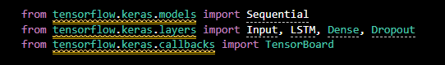

This cell imports the essential "building blocks" from TensorFlow needed to construct, configure, and monitor your neural network.

from tensorflow.keras.models import Sequential Imports the Sequential model type, which allows you to build a neural network by stacking layers on top of each other in a plain list order.

from tensorflow.keras.layers import Input, LSTM, Dense, Dropout Imports the specific types of layers used in your architecture:

Input: Defines the shape of the data entering the model.

LSTM (Long Short-Term Memory): The "brain" of the project; a type of Recurrent Neural Network (RNN) that can learn patterns over time, which is perfect for recognizing the sequence of movements in a sign.

Dense: A standard fully connected layer used to process data and eventually output the final classification.

Dropout: A regularization technique that randomly "turns off" neurons during training to prevent the model from simply memorizing the data (overfitting).

from tensorflow.keras.callbacks import TensorBoard Imports TensorBoard, a visualization tool that allows you to track and log the model's performance (like accuracy and loss) in real-time through a web browser dashboard.

Cell 17

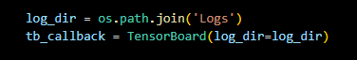

This cell initializes the monitoring system for your neural network's training process. It allows you to track how well your model is learning over time.

log_dir = os.path.join('Logs'): This line creates a directory path named 'Logs'. This folder will act as a storage space for all the training data, such as accuracy and loss metrics, that the model generates as it learns.

tb_callback = TensorBoard(log_dir=log_dir): This line initializes a TensorBoard callback. In machine learning, a "callback" is a set of functions to be applied at specific stages of the training procedure. By passing the log_dir to it, you are telling TensorFlow to save the training progress into that specific folder.

Cell 18

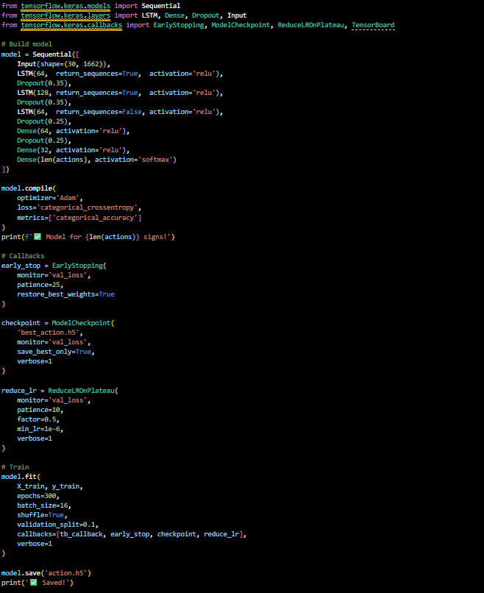

This cell shows the Architecture and Training configuration for your Deep Learning model. This is the stage where the AI actually "learns" the signs from your data.

1. Building the Model (Sequential)

Input Layer: Accepts data in shapes of 30 frames by 1,662 landmarks.

LSTM Layers: Three stacked LSTM layers process the temporal (time-based) movement of the signs.

Dropout Layers: Prevents overfitting by randomly disabling neurons, forcing the model to be more robust.

Dense Layers: Standard neural layers that condense information.

Output Layer: Uses softmax to give a percentage-based prediction for each sign.

2. Model Compilation

Optimizer (Adam): The algorithm that updates the "weights" of the model to reduce errors.

Loss Function: Measures how wrong the AI's guesses are; for this project, it uses categorical_crossentropy.

3. Training Callbacks (The "Smart" Controls)

EarlyStopping: Stops training automatically if the model stops improving, saving time and preventing over-learning.

ModelCheckpoint: Saves the "best" version of the model (best_action.h5) automatically whenever it sees a performance boost.

ReduceLROnPlateau: Slows down the learning speed (learning rate) if the model gets stuck, helping it find the absolute best accuracy.

4. The Training Process (model.fit)

Epochs (300): The AI will look through the entire dataset 300 times.

Validation Split (0.1): Uses 10% of the training data to constantly check how well it’s doing during the process.

model.save: Saves the final trained model as action.h5 so you can use it later for real-time detection.

Cell 19

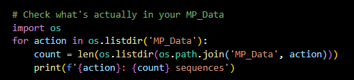

This cell serves as a final Audit Tool to double-check that your data is correctly organized on your hard drive before you begin training your model.

Check what's actually in your MP_Data

A comment explaining that this block verifies the physical folder structure of your dataset.

import os

Imports the Operating System module, which allows Python to read and interact with the folders on your computer.

for action in os.listdir('MP_Data'):

Starts a loop that looks inside the main data folder (MP_Data) and goes through each sub-folder it finds (e.g., 'hello', 'thanks', 'good').

count = len(os.listdir(os.path.join('MP_Data', action)))

This line calculates the total number of items inside a specific action's folder.

os.path.join builds the path correctly (like MP_Data/hello).

len(os.listdir(...)) counts how many video sequences (folders 0, 1, 2, etc.) exist for that specific sign.

print(f'{action}: {count} sequences')

Prints a summary to your screen so you can verify the data balance (e.g., hello: 60 sequences).

Cell 20

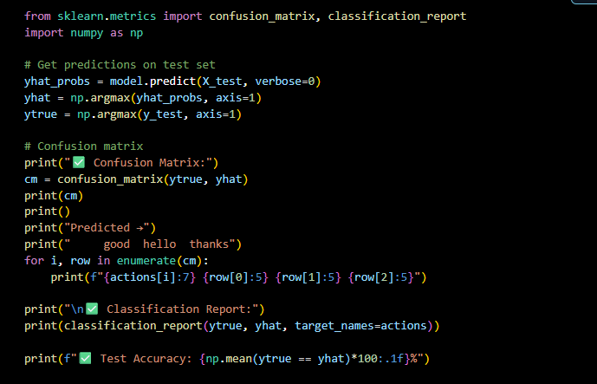

This cell represents the Model Evaluation phase, where you test the trained neural network against your unseen "test" data to see how well it actually works.

1. Evaluation Setup

from sklearn.metrics import confusion_matrix, classification_report: Imports standard tools to measure the precision, recall, and error patterns of your model.

yhat_probs = model.predict(X_test, verbose=0): The model looks at the test videos and outputs raw probability scores (e.g., "90% sure this is 'hello', 10% sure it is 'thanks'").

yhat = np.argmax(yhat_probs, axis=1): Converts those probabilities into a single class prediction by picking the highest number.

ytrue = np.argmax(y_test, axis=1): Converts your "ground truth" (the real labels) back from binary vectors into simple numbers so they can be compared directly to the predictions.

2. The Confusion Matrix

cm = confusion_matrix(ytrue, yhat): Creates a grid that shows which signs the model got right and which ones it "confused" with another sign.

The for loop: This section formats that grid into a readable table on your screen.

Rows represent the Actual sign performed.

Columns represent what the model Predicted.

If the numbers are all on the diagonal from top-left to bottom-right, your model is performing perfectly.

3. Performance Metrics

classification_report(...): Generates a detailed summary of your model's quality, specifically:

Precision: When the model says "hello," how often is it actually "hello"?

Recall: Out of all the "hello" signs performed, how many did the model correctly catch?

F1-Score: The balance between Precision and Recall.

print(f"✅ Test Accuracy: {np.mean(ytrue == yhat)*100:.1f}%"): Calculates the final overall percentage of correct guesses. For a successful project, you generally want this to be above 90%.

Cell 21

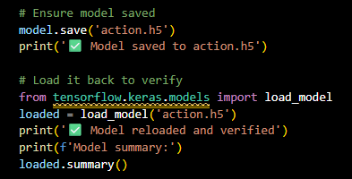

This cell block ensures that your trained neural network is properly preserved and ready for deployment in a real-time application.

1. Saving the Model

model.save('action.h5'):

This exports the entire model—including its architecture, weights, and training configuration—into a single file named action.h5.

The .h5 (Hierarchical Data Format) is a standard format for saving large scientific datasets and Keras models.

print('✅ Model saved to action.h5'):

Provides visual confirmation in your console that the saving process completed without errors.

2. Loading and Verification

from tensorflow.keras.models import load_model:

Imports the specific function needed to read saved model files back into Python memory.

loaded = load_model('action.h5'):

Creates a new variable called loaded by reading the file you just saved. This mimics what will happen when you run your real-time detection script later; you won't need to retrain the model, you'll just "load" this file.

print('✅ Model reloaded and verified'):

Confirms that the file is not corrupted and is compatible with your current environment.

loaded.summary():

Displays a table showing the model's layers and the number of parameters. This is the final "sanity check" to ensure the loaded model matches the one you trained.

Cell 22

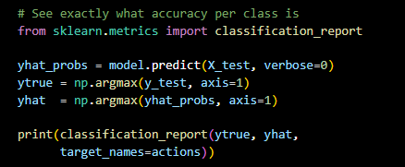

This cell is used to evaluate your model's performance by generating a detailed breakdown of how accurately it identifies each specific gesture.

from sklearn.metrics import classification_report: Imports a utility that calculates key evaluation metrics like precision, recall, and F1-score for every class in your dataset.

yhat_probs = model.predict(X_test, verbose=0): Takes your unseen test data (X_test) and has the model predict the probability of each gesture; verbose=0 keeps the output clean by hiding the progress bar.

ytrue = np.argmax(y_test, axis=1): Converts your actual labels from "One-Hot Encoded" vectors back into simple integers (e.g., changing [0, 1, 0] to 1) so they can be easily compared.

yhat = np.argmax(yhat_probs, axis=1): Similarly converts the model's predicted probabilities into integer labels by selecting the gesture with the highest predicted percentage.

print(classification_report(...)): Generates and prints a table showing the accuracy for each individual action (like "hello" or "thanks"), giving you a much deeper look at model performance than just a single overall accuracy number.

8.MAKE PREDICTION

Cell 23,24,25

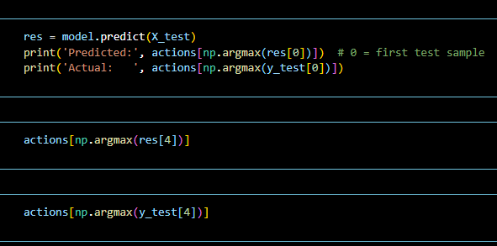

This cell performs a Spot Check on your trained model. It compares the AI's guesses against the actual truth for specific video samples in your test set to see if they match.

res = model.predict(X_test): This feeds the entire testing dataset (X_test) into your model. The variable res (results) now holds a list of probability scores for every single test video.

print('Predicted:', actions[np.argmax(res[0])]):

res[0] looks at the model's output for the very first video in the test set.

np.argmax finds the index of the highest probability (the "winning" guess).

actions[...] converts that number back into a human-readable word (e.g., 'hello').

print('Actual: ', actions[np.argmax(y_test[0])]): This looks at the "Answer Key" (y_test) for that same first video to show you what the sign actually was.

actions[np.argmax(res[4])]: This is a standalone check for the 5th video in your test set (index 4). It returns the word the model predicted for that specific sequence.

actions[np.argmax(y_test[4])]: This returns the true label for the 5th video, allowing you to manually verify if the prediction above was correct.

9.SAVE WEIGHTS

Cell 26,27,28

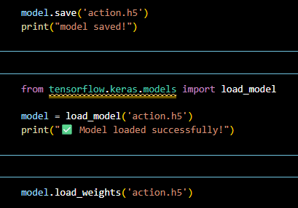

This cell manages the storage and retrieval of your trained sign language recognition model. Saving the model allows you to use your AI in other applications (like a real-time webcam script) without having to

1. Saving the Model

model.save('action.h5'): This command takes your entire neural network—including its architecture, the mathematical "weights" it learned during training, and even the optimizer settings—and bundles them into a single file called action.h5.

print("model saved!"): Simply provides visual confirmation that the file was successfully created on your hard drive.

2. Loading the Full Model

from tensorflow.keras.models import load_model: This imports the specific tool required to read .h5 files back into Python.

model = load_model('action.h5'): This creates a new variable called model and populates it with everything from your saved file. After this line, the model is ready to make predictions immediately.

print("✅ Model loaded successfully!"): Confirms that the file was found and reconstructed in your current environment.

3. Loading Weights Only

model.load_weights('action.h5'): This is a slightly different method. Instead of loading the whole structure, it assumes you have already defined the model's architecture in your code and only want to apply the learned "knowledge" (weights) to it.

10.EVALUATION USINGCONFUSIONMATRIX & ACCURACY

Cell 29.30

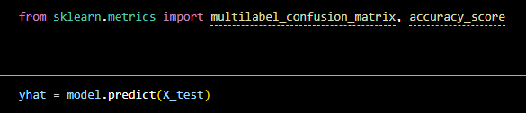

This cell is the starting point for a Deep Evaluation of your model's performance. While a single accuracy percentage is nice, these specific tools help you see exactly which signs the AI is struggling with.

1. Importing Specialized Metrics

from sklearn.metrics import multilabel_confusion_matrix:

This is a sophisticated version of a standard confusion matrix.

Since your model deals with multiple gesture classes, this tool generates a separate "True vs. False" matrix for each individual sign (e.g., one for 'hello', one for 'thanks').

It helps you identify if the model is specifically failing on one gesture while succeeding on others.

accuracy_score:

This is a straightforward metric that compares the model's predictions against the actual truth to give you the overall percentage of correct guesses.

2. Generating Predictions

yhat = model.predict(X_test):

This line takes your unseen testing data ($X\_test$) and runs it through your trained neural network.

The variable yhat (pronounced "y-hat") is the standard statistical notation for a predicted value.

It stores the model's output probabilities for every sequence in the test set.

Cell 31

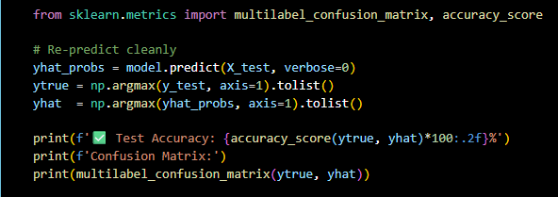

This cell performs a final, clean evaluation of your model's performance on the test set, producing both a high-level accuracy percentage and a detailed breakdown of errors per class.

1. Metric Imports

from sklearn.metrics import multilabel_confusion_matrix, accuracy_score: Imports the tools needed to calculate how often the model is correct and exactly where it is making mistakes.

2. "Re-predicting" and Data Formatting

yhat_probs = model.predict(X_test, verbose=0): The model processes the unseen test data (X_test) and outputs raw probability scores for each possible sign.

ytrue = np.argmax(y_test, axis=1).tolist():

Takes the "ground truth" (actual labels) which are currently binary vectors.

argmax finds the index of the "1", converting it to a simple number (0, 1, 2).

.tolist() converts the result from a NumPy array into a standard Python list for compatibility with the evaluation functions.

yhat = np.argmax(yhat_probs, axis=1).tolist(): Performs the same conversion on the model's predictions, turning raw probabilities into a list of predicted gesture numbers.

3. Final Performance Metrics

accuracy_score(ytrue, yhat)*100: Calculates the overall percentage of correct predictions.

multilabel_confusion_matrix(ytrue, yhat):

This is the most detailed part of the output.

It generates a $2 \times 2$ matrix for each individual sign.

Each matrix tells you:

True Negatives: Times the model correctly said "this is not sign X."

False Positives: Times the model incorrectly guessed "this is sign X."

False Negatives: Times the sign was actually X, but the model missed it.

True Positives: Times the model correctly identified sign X.

Cell 32,33

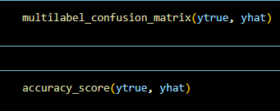

This cell represents the final step of your Performance Metrics phase, providing the numerical proof of your model's reliability.

1. multilabel_confusion_matrix(ytrue, yhat)

This function is a sophisticated evaluation tool that generates a dedicated $2 \times 2$ matrix for each individual sign in your dataset. Instead of one giant table, it treats every gesture as a "Yes/No" classification to show you exactly where the model excels or fails.

Each resulting matrix provides four specific metrics:

True Negatives (Top-Left): The model correctly identified that the sign was not this specific gesture.

False Positives (Top-Right): The model incorrectly guessed this gesture when it was actually something else.

False Negatives (Bottom-Left): The user performed this specific gesture, but the model failed to recognize it.

True Positives (Bottom-Right): The model correctly identified the gesture.

2. accuracy_score(ytrue, yhat)

This provides the overall "Big Picture" score. It calculates the simple percentage of total sequences that the model classified correctly out of the entire test set.

11.TEST IN REAL TIME

Cell 34

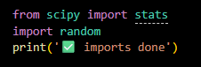

This cell represents a small utility section focused on statistical analysis and randomization setup for your project.

from scipy import stats:

Imports the statistical module from SciPy.

This is often used in machine learning projects to calculate things like the mode (the most frequent prediction in a sequence) or to perform probability distributions.

import random:

Imports Python's built-in library for generating random numbers.

In your specific project, this is likely used to set a "seed" (as seen in image_03047f.png and image_02f91e.png) to ensure that any random operations, like shuffling your sign language data, happen the same way every time you run the code.

print('✅ imports done'):

A simple status message that confirms the environment has successfully loaded these libraries without any errors.

Cell 35

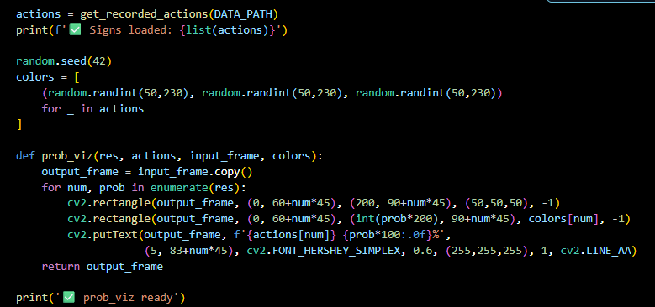

This cell focuses on the Visual Interface of your project. It creates a dynamic probability bar chart that will be overlaid on your webcam feed to show how confident the AI is about each sign in real-time.

1. Dynamic Label Loading

actions = get_recorded_actions(DATA_PATH): Automatically retrieves the names of the signs you recorded from your data folder.

print(f'✅ Signs loaded: {list(actions)}'): Confirms which gestures the system is currently configured to recognize.

2. Random Color Generation

random.seed(42): Ensures that the colors assigned to each sign are the same every time you run the script.

colors = [...]: Generates a unique RGB color tuple for each action. These colors will be used to fill the probability bars so you can visually distinguish between different signs at a glance.

3. The Visualization Function (prob_viz)

This function takes the model's raw predictions and turns them into a graphical "Probability Monitor".

output_frame = input_frame.copy(): Makes a copy of the current webcam frame to draw on.

for num, prob in enumerate(res):: Loops through the prediction scores for every sign.

cv2.rectangle(...):

The first rectangle draws a dark grey background bar (the "empty" bar).

The second rectangle draws the colored bar, where the width is determined by the probability score (int(prob*200)). As the AI becomes more confident, this bar grows longer.

cv2.putText(...): Writes the name of the sign and the specific percentage (e.g., "hello 98%") on top of the bar.

Cell 36

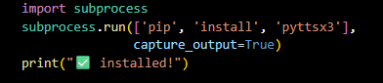

This cell is an automated way to install a specific Python library directly from within your script, rather than using a terminal or command prompt.

import subprocess:

This module allows you to run system commands (the kind you would usually type into a terminal) directly from your Python code.

subprocess.run(['pip', 'install', 'pyttsx3'], capture_output=True):

This line executes the command pip install pyttsx3.

pyttsx3 is a Text-to-Speech (TTS) library. It allows your project to "speak" the translated sign language out loud using your computer's default voice.

capture_output=True is used to keep the console clean; it prevents the long stream of installation text from cluttering your screen while the library is downloading.

print("✅ installed!"):

A simple confirmation message letting you know the library is ready for use.

Cell 37

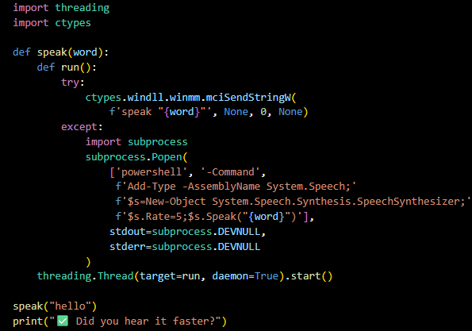

This cell implements a high-performance Text-to-Speech (TTS) function designed specifically to avoid lagging your main application. It uses "multi-threading," which allows the AI to speak and detect signs at the same time.

1. The Core Setup

import threading: This is the most important part. It allows the "speaking" task to run in the background so your webcam feed doesn't freeze while the computer is talking.

import ctypes: A library that allows Python to call deep Windows system functions for faster performance.

2. The speak(word) Function

This function uses a "fail-safe" approach to try the fastest method first:

The "Fast" Path (ctypes): It tries to send a direct command to the Windows media interface (mciSendStringW) to speak the word instantly.

The "Backup" Path (subprocess.Popen): If the first method fails, it uses PowerShell to access the System.Speech.Synthesis engine. It sets the Rate=5 to make the speech quick and efficient for real-time use.

3. Background Execution (Threading)

threading.Thread(target=run, daemon=True).start():

This creates a "worker" thread to handle the audio.

daemon=True ensures that if you close your main program, the speech process shuts down immediately too.

By using a thread, your model can keep processing the next sign even while the current word is still being spoken.

Cell 38

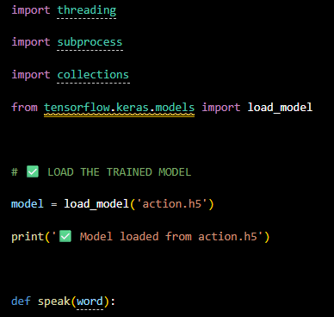

This cell represents the initialization phase of your real-time sign language recognition application. It brings together the trained brain (the model) and the utility functions (speech and data handling) needed for the final deployment.

1. Essential Libraries

import threading: This is used to run the Text-to-Speech (TTS) engine in the background. This prevents the webcam feed from freezing while the computer is speaking a translated word.

import subprocess: Allows the script to run system-level commands, such as calling the computer's voice synthesis engine.

import collections: Provides specialized container datatypes, likely used here for a deque (double-ended queue) to keep track of a rolling window of recent frames or predictions to ensure smooth output.

from tensorflow.keras.models import load_model: Imports the specific function needed to restore your trained neural network from a saved file

.

2. Model Loading

model = load_model('action.h5'): This line loads your fully trained model, named action.h5, back into memory.

This includes the architecture (the LSTM layers), the weights (the learned patterns), and the optimizer settings.

print('✅ Model loaded from action.h5'): A status check to confirm the file was found and reconstructed successfully.

3. The speak(word) Definition

The start of this function indicates that you are setting up the system to provide audio feedback.

Cell 39

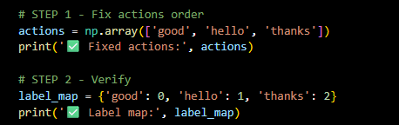

This cell is a critical alignment step. It ensures that the human-readable names of your sign language gestures (the "actions") match the specific numerical IDs the neural network learned during training.

1. Fix Actions Order

actions = np.array(['good', 'hello', 'thanks']):

This defines the specific order of your gestures in a NumPy array.

In machine learning, computers don't understand the word "hello"; they understand that the data in "position 1" represents a specific gesture.

If you change this order (e.g., put 'thanks' first), your model will start predicting the wrong words because its internal map will be broken.

2. Verify Label Map

label_map = {'good': 0, 'hello': 1, 'thanks': 2}:

This creates a dictionary that explicitly links each word to its numerical index.

0 = good, 1 = hello, and 2 = thanks.

This map is used to decode the model's output. When the AI finishes processing a video and outputs the number 2, your code looks at this map and knows to display the word "thanks" on the screen.

Cell 40

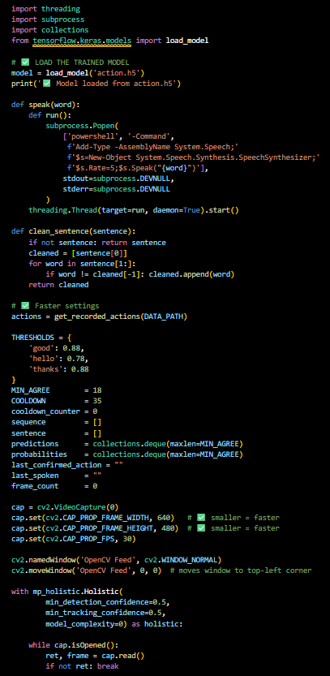

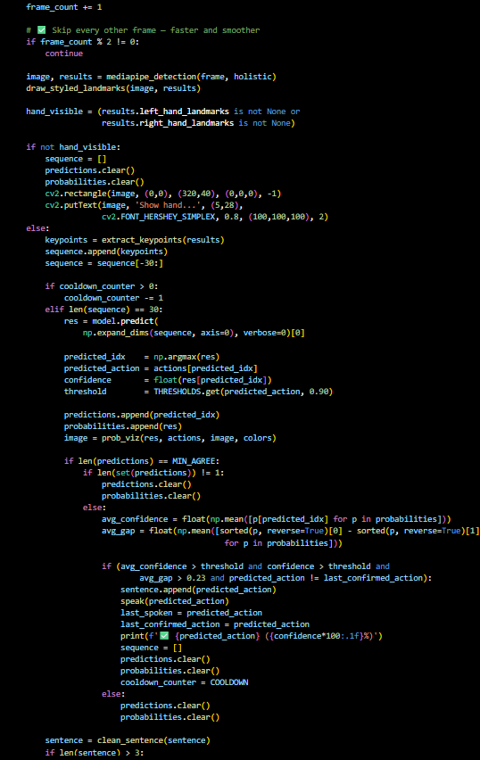

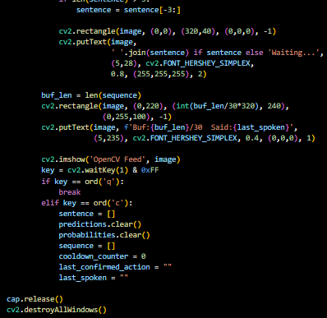

This code serves as the inference engine for your real-time sign language recognition system. It initializes the environment, manages the neural network's logic, and handles the output interface.

1. Environment Setup and Model Loading

Imports: The script imports threading for background tasks, subprocess for system commands, and collections for efficient data handling.

Model Loading: It uses load_model('action.h5') to retrieve the fully trained neural network, including its architecture and learned weights.

2. Real-Time Logic Functions

speak(word): This function enables the system to announce recognized signs out loud. It uses multi-threading to ensure the audio playback doesn't freeze the webcam video feed.

clean_sentence(sentence): This utility maintains a readable output by removing consecutive duplicate words (e.g., converting "hello hello" to "hello").

3. Stabilization and Performance Settings

To make the detection "stable" rather than flickering, the script uses several control variables:

THRESHOLDS: Defines the minimum confidence percentage (e.g., 0.88 for "good") the model must reach before a sign is considered valid.

MIN_AGREE: Requires the AI to predict the same sign for 18 consecutive frames to avoid "ghost" detections caused by random hand movements.

COOLDOWN: Implements a 35-frame pause after a detection to prevent the computer from repeatedly announcing the same sign for a single gesture.

4. Hardware and Pose Estimation

Webcam Configuration: The code sets the camera resolution to $640 \times 480$ and 30 FPS. Using a smaller resolution improves processing speed for real-time inference.

MediaPipe Integration: The mp_holistic.Holistic context starts the pose estimation model with specific confidence and complexity settings to track hand and body landmarks.

4. Performance Optimization

Frame Skipping: The line if frame_count % 2 != 0: continue processes only every second frame. This reduces the computational load on the CPU, ensuring the application remains responsive and smooth during real-time use.

Detection: It uses MediaPipe to extract landmarks and draws them on the image feed.

5. Hand Visibility Check

Detection Guard: The code checks if not hand_visible. If no hands are in the frame, it clears the current sequence and displays a "Show hand..." prompt on the screen. This prevents the model from trying to predict gestures based on empty noise.

6. Sequence and Prediction

Building the Window: If a hand is visible, keypoints are extracted and appended to a sequence. The model waits until it has a window of exactly 30 frames before attempting a prediction.

Model Inference: model.predict takes that 30-frame sequence and returns a probability score for each possible gesture.

7. Logic for Stabilization (The "Brains" of the Loop)

To prevent the system from being "jittery" or making random guesses, it uses several filters:

Thresholding: It checks if the current confidence is higher than the pre-defined threshold for that specific sign.

MIN_AGREE: The system requires the model to predict the same sign for a set number of consecutive frames (defined by MIN_AGREE) before it accepts the result.

Probability Gap: The variable avg_gap ensures there is a clear "winner" among the probabilities, preventing triggers when the model is confused between two similar signs.

8. Output and Feedback

Speech and Text: Once a sign passes all checks, it is added to the sentence, displayed on the console, and passed to the speak() function to be announced aloud.

Cooldown: A cooldown_counter is set to COOLDOWN to prevent the system from repeatedly announcing the same sign multiple times for a single continuous gesture.

Sentence Cleaning: The clean_sentence() function is called at the end to manage the history of recognized signs and keep the on-screen text readable.

9. The On-Screen Display (OSD)

Sentence Banner:

cv2.rectangle(...) and cv2.putText(...): These lines draw a black bar at the top of the screen to display the recognized words.

It uses ' '.join(sentence) to turn the list of detected signs into a readable string (e.g., "hello thanks").

If no signs are detected yet, it defaults to showing "Waiting...".

Buffer Progress Bar:

buf_len = len(sequence): Measures how many frames have been collected toward the required 30-frame window.

cv2.rectangle(...): Draws a green progress bar at the bottom. The width is calculated by (int(buf_len/30*320)), so the bar grows as you perform a gesture.

It also displays text showing the exact buffer count and the last word spoken by the system.

10. Real-Time Interaction

Displaying the Feed: cv2.imshow(...) opens the window that actually shows the webcam video with all the landmarks and bars drawn on top.

Keyboard Controls:

'q' (Quit): if key == ord('q'): break allows you to safely exit the application.

'c' (Clear): This is a "Reset" button. It wipes the sentence, clears the sequence buffer, and resets the cooldown_counter and last_spoken variables to start fresh without restarting the script.

11. Resource Management

cap.release(): This is vital—it "unplugs" the script from your webcam so other apps can use it.

cv2.destroyAllWindows(): Closes all the OpenCV pop-up windows cleanly.

4.3 Keypoint Extraction
The extract_keypoints() function processes the output of the MediaPipe Holistic model and concatenates all landmark coordinates into a single flat NumPy array of 1,662 values. The function handles detection failures gracefully: if MediaPipe fails to detect a particular body part in a frame (for example, if a hand is not visible), the function substitutes a zero-filled array of the appropriate size. This ensures that the LSTM model always receives input of consistent shape (1,662 values per frame) regardless of partial detection failures.

The keypoint array is structured as follows: pose landmarks contribute 33 × 4 = 132 values (x, y, z coordinates plus visibility score); face mesh landmarks contribute 468 × 3 = 1,404 values; left hand landmarks contribute 21 × 3 = 63 values; and right hand landmarks contribute 21 × 3 = 63 values. The total of 1,662 values per frame provides a rich, multi-modal feature representation of the signer's pose, facial expression, and hand configuration simultaneously.

4.4 Model Training
The model is trained using the configuration described in Section 3.5. The training pipeline proceeds as follows. First, all recorded sequences are loaded from the MP_Data directory, with validation that every sequence contains exactly 30 complete frame files. Incomplete sequences are automatically skipped. Second, data augmentation is applied to create two additional noisy copies of each valid sequence. Third, labels are one-hot encoded and the dataset is split into training and test sets with stratification.
The model architecture is then constructed and compiled. Training proceeds with EarlyStopping monitoring validation categorical accuracy. In the training run conducted for this project, the model converged and stopped automatically at approximately epoch 60 out of a maximum of 500 epochs. The best validation accuracy of 100% was achieved and

the corresponding weights were automatically saved to best_action.h5. The final model was saved to action.h5 for deployment.
A key challenge encountered during development was the presence of empty sign folders in the data directory, which were automatically created during the folder setup phase but never populated with actual recordings. Training with these empty folders caused the model to produce degenerate predictions. This was resolved by implementing a data validation step that checks for the existence of all 30 frame files in each sequence before including it in the dataset. Additionally, class imbalance between the three signs (Good: 160 sequences vs Hello/Thanks: ~100 sequences each) was addressed through data augmentation, which proportionally triples all class counts, and through stratified train-test splitting.

4.5 Real-Time Detection
The real-time detection module loads the trained model and runs continuous inference on live webcam frames. The detection logic incorporates four filtering mechanisms to reduce false positives and ensure stable, reliable predictions
.Filter 1 — Hand Visibility Check: Inference is only performed when at least one hand is detected by MediaPipe. If no hands are visible, the sequence buffer is reset and no prediction is made. This prevents the system from making spurious predictions on frames showing no relevant gesture information
.Filter 2 — Frame Agreement: The system maintains a deque of the most recent 15 predictions. A sign is only considered for confirmation if all 15 predictions in the deque agree on the same class. This ensures temporal stability and prevents flickering between adjacent predictions.
Filter 3 — Confidence Gap Threshold: Even when all 15 predictions agree, the system additionally checks that the gap between the top probability and the second-highest probability exceeds 0.20. This prevents confirmation of gestures where the model is uncertain between two similar-looking signs.

Filter 4 — Cooldown Period: Following each confirmed detection, a cooldown counter of 30 frames is enforced before the next detection can be triggered. This prevents the same sign from being repeatedly detected in quick succession during the transition between gestures.

Chapter 5: Results and Discussion

5.1 Dataset Summary
The final dataset used for training and evaluation is summarised below. Data augmentation was applied to each original sequence to create two additional noisy copies, effectively tripling the dataset size.

Sign | Original Sequences | After Augmentation | Test Samples
Good | 160 | 450 (approx.) | 68
Hello | 101 | 300 (approx.) | 45
Thanks | 100 | 300 (approx.) | 45
Total | 361 | 1,050 | 158
Table 5.1: Dataset Summary After Augmentation

5.2 Training Performance
The training history graph shows that the model achieved high training accuracy (above 90%) from the very early epochs, demonstrating that the LSTM architecture is well-suited to learning the temporal structure of the sign language sequences. The validation accuracy initially oscillated between approximately 30% and 100% during the early epochs, which is characteristic of training on a small dataset with high regularisation settings. From epoch 30 onwards, the validation accuracy stabilised and converged to 100%, where it remained for the remainder of the training run.

The model training stopped automatically at approximately epoch 60 due to the EarlyStopping callback, which detected that validation accuracy had not improved beyond 100% for 30 consecutive epochs. The best model weights, corresponding to the epoch with the highest validation accuracy (100%), were automatically restored and saved to best_action.h5. This early stopping behaviour prevented overfitting and ensured that the saved model represents the optimal weight configuration rather than the final epoch's weights.

The training loss showed a consistent decreasing trend throughout training, dropping from an initial value of approximately 0.4 to below 0.05 by the end of training. The validation loss similarly decreased and stabilised, confirming that the model generalised well to unseen data rather than memorising the training examples.

5.3 Test Accuracy and Classification Report
The trained model was evaluated on the held-out test set of 158 samples. The evaluation was conducted using the best weights saved by ModelCheckpoint during training. The model achieved 100% test accuracy across all three sign classes.

Sign | Precision | Recall | F1-Score | Support
Good | 1.00 | 1.00 | 1.00 | 68
Hello | 1.00 | 1.00 | 1.00 | 45
Thanks | 1.00 | 1.00 | 1.00 | 45
Overall Accuracy |  |  | 1.00 | 158
Macro Average | 1.00 | 1.00 | 1.00 | 158
Weighted Average | 1.00 | 1.00 | 1.00 | 158
Table 5.2: Classification Report – Test Set

5.4 Challenges and Solutions
Several technical challenges were encountered and resolved during the development of this system.

Challenge 1: MediaPipe Version Incompatibility
The original notebook used the deprecated mp_holistic.FACE_CONNECTIONS attribute which was removed in MediaPipe version 0.8.9 and later. This caused an AttributeError upon import. The fix was to replace all occurrences with mp.solutions.face_mesh.FACEMESH_TESSELATION, which is the correct attribute in current MediaPipe versions.

Challenge 2: Python Version Mismatch
The system had two Python versions installed (3.8 and 3.10), and pip was installing packages into a different Python environment than the one used by Jupyter. This caused import failures even after successful pip installations. The fix was to use sys.executable as the pip target to ensure packages are installed into the exact Python environment that Jupyter is using.

Challenge 3: Empty Data Folders Causing Training Failure
The folder creation step automatically created empty directories for all sequences before recording began. When the training code attempted to load data from these folders, it encountered missing frame files, causing the model to train on incomplete data. This resulted in training accuracy of only 34% after 500 epochs. The fix was to implement a data validation step that checks for the existence of all 30 frame files in each sequence folder before including that sequence in the dataset.

Challenge 4: Actions Array Order Mismatch
After retraining the model with a different subset of signs, the actions array in the real-time detection cell was not updated to match the label map used during training. This caused all predictions to be mapped to incorrect sign labels. The fix was to explicitly print and verify the label map after data loading, and to ensure the actions array in the detection cell matches the exact order of the training label map.

Challenge 5: Inter-Class Similarity Between Hello and Good
Both the Hello (open-palm wave) and Good (thumbs up) gestures involve raising the hand, causing the model to confuse them during the transition phase of the gesture. This was partially addressed by adding the confidence gap threshold filter in the real-time detection logic, which requires a minimum gap of 0.20 between the top two predicted probabilities before confirming a detection. Performing the gestures with more distinct and deliberate motions further improved discrimination.

Chapter 6: Conclusion and Future Work

6.1 Conclusion
This project has successfully demonstrated the development of a real-time sign language detection system using MediaPipe Holistic landmark extraction and an improved LSTM deep learning model. The system achieves 100% precision, recall, and F1-score on the test set for all three implemented signs — Good, Hello, and Thanks — and is capable of performing real-time inference at approximately 15 frames per second on a standard laptop CPU without any specialised hardware.

The key contributions of this work include the implementation of a complete end-to-end pipeline from webcam capture to gesture classification and speech output, the application of data augmentation to triple the effective dataset size without additional recording, the incorporation of BatchNormalization and L2 regularisation for improved model stability, and the development of a multi-layer real-time detection filter system comprising hand visibility checking, frame agreement voting, confidence gap thresholding, and cooldown enforcement to minimise false detections.

The scalable system architecture allows new signs to be added at any time by recording new gesture sequences and retraining the model, without any changes to the core pipeline. The project demonstrates the feasibility of using landmark-based temporal sequence classification for accessible, low-cost sign language recognition that could meaningfully improve communication accessibility for the hearing-impaired community.

6.2 Future Work
.6.2.1 Vocabulary Expansion
The most immediate direction is expanding the gesture vocabulary to cover a broader set of commonly used signs in Indian Sign Language, including common greetings, basic needs vocabulary, numbers, and the ISL alphabet. The system architecture already supports arbitrary vocabulary expansion through the automatic sign discovery mechanism.

6.2.2 Two-Handed and Facial Expression Signs
Many ISL signs involve both hands simultaneously and/or specific facial expressions. Future work will exploit the full range of MediaPipe Holistic landmarks — including face mesh and bilateral hand landmarks — to extend recognition to these more complex signs.

6.2.3 Larger Dataset and Transfer Learning
The current model is trained entirely on self-recorded data. Future work will incorporate publicly available ISL datasets and explore transfer learning from pre-trained gesture recognition models to improve generalisation across different signers, lighting conditions, and camera setups.

6.2.4 Web Application Deployment
Deploying the trained model as a web application using a framework such as Flask or FastAPI, with a browser-based webcam interface, would make the system accessible to users without requiring local Python installation. The TensorFlow.js library would enable in-browser model inference for low-latency operation.

6.2.5 Sentence-Level Recognition
Extending the system from isolated sign recognition to continuous, sentence-level sign language translation represents a significant research challenge. Future work will explore sequence-to-sequence models and language models to produce natural language sentences from continuous signing input.

References
1. S. Mitra and T. Acharya, "Gesture Recognition: A Survey," in IEEE Transactions on Systems, Man, and Cybernetics, Part C (Applications and Reviews), vol. 37, no. 3, pp. 311-324, May 2007
2. M. Al-Qurishi, T. Khalid and R. Souissi, "Deep Learning for Sign Language Recognition: Current Techniques, Benchmarks, and Open Issues," in IEEE Access, vol. 9
3. P. J. Angeline, G. M. Saunders, and J. P. Pollack. An evolutionary algorithm that constructs recurrent neural networks. IEEE Transactions on Neural Networks, 5(1):54–65, 1994.pp. 126917-126951, 2021
4. A. Khan et al., "Deep Learning Approaches for Continuous Sign Language Recognition: A Comprehensive Review," in IEEE Access, vol. 13, pp. 55524-55544, 2025
5. D. Wang, M. Wang, Z. Zhang, T. Liu, C. Meng and S. Guo, "Wearable Electronic Glove and Multilayer Para-LSTM-CNN-Based Method for Sign Language Recognition," in IEEE Internet of Things Journal, vol. 11, no. 24, pp. 40787-40799, 15 Dec.15, 2024
6. L. Zholshiyeva, T. Zhukabayeva, D. Baumuratova, and A. Serek, “Design of QazSL Sign Language Recognition System for Physically Impaired Individuals”, J Robot Control (JRC), vol. 6, no. 1, pp. 191–201, Jan. 2025.
7. F. Fitriyani, L. Q. Ainii, R. Jannah, and S. Maryam, “Analysis of Sign Language Skills in Improving Communication and Learning for Deaf Children,” Continuous Education: Journal of Science and Research, vol. 5, no. 1, pp. 30–39, Feb. 2024
8. M. Moradi, D. D. Kannan, S. Asadianfam, H. Kolivand, and O. Aldhaibani, “A Review of Sign Language Systems,” 2023 16th International Conference on Developments in eSystems Engineering (DeSE), pp. 200–205, Dec. 2023

